Lesson plan …
[add title]
In this lesson plan the students …

EXPERIENCES
Students
- ……
- ……
- ……
TARGETED COMPETENCES
Students
- ……
- ……
- ……
PROCEDURE
BEFORE

DURING

AFTER
FINAL PRODUCT FOR THE PORTFOLIO
- …
TOOLS AND RESOURCES
- …

You may wish to use the following icons:

 | individual work |  | pair or group work |  | discussion
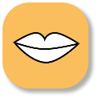 | speaking | 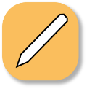 | writing | 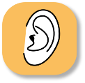 | listening
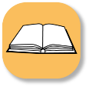 | reading |  | observing |  | reflexion
 | question | 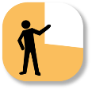 | presentation | 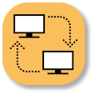 | using ICT

